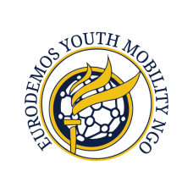
icrp

Application Form
PARTICIPATION OF “REFUGEES – RELIGION, FUTURE, GENERATION, STEREOTYPES” PROJECT
DECEMBER 2016 – DOMBÓVÁR

General information
First Name:
Last Name:
Citizenship:

Date of Birth: (dd/mm/yy) |  | Place of Birth:
Gender: | Male: ☐ Female: ☐

Telephone number:
E-mail address:

Travel documents
Type of document:
Full document no.:
Expiration date:

Special needs
Vegetarian, non-vegetarian, diet:
Health issues:
Medicines:

Who to inform in case of emergency (name, status of person and phone number):

Language level of knowledge
English: | Fluent ☐ Good ☐ Fair ☐

Declarations
I declare that I have a permanent or temporary address or residence permit in the country I am representing
Yes ☐ No ☐

I declare that I have read and agreed on terms of the Participant Declaration (http://culturalrelations.org/Files/Forms/Participants_Declaration.pdf)
Yes ☐ No ☐

Intentions
Please state your reasons for wishing to attend the project (500 words max):

Date: | Signature:

Kulturális Kapcsolatokért Alapítvány
(Institute for Cultural Relations Policy)
Web: culturalrelations.org
icrp
Blog: blog.culturalrelations.org
Facebook: /culturalrelations
Twitter: /ICRP_Budapest
Linkedin: /company/institute-for-cultural-relations-policy
YouTube: /icrpbudapest

